**PictureBox Control**

The PictureBox control is used for displaying images on the form. The Image property of the control allows you to set an image both at design time or at run time.

Let's create a picture box by dragging a PictureBox control from the Toolbox and dropping it on the form.

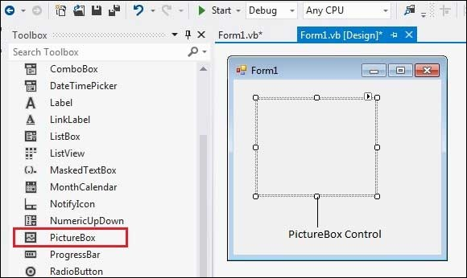

**Properties of the PictureBox Control**

The following are some of the commonly used properties of the PictureBox control

1. image

Gets or sets the image that is displayed in the control.

2. ImageLocation

Gets or sets the path or the URL for the image displayed in the control.

3. SizeMode

Determines the size of the image to be displayed in the control. This property takes its value from the PictureBoxSizeMode enumeration, which has values −

Normal − the upper left corner of the image is placed at upper left part of the picture box

StrechImage − allows stretching of the image

AutoSize − allows resizing the picture box to the size of the image

CenterImage − allows centering the image in the picture box

Zoom − allows increasing or decreasing the image size to maintain the size ratio.

4. TabStop

Specifies whether the user will be able to focus on the picture box by using the TAB key.

5.Text

Gets or sets the text for the picture box.

**Events of the PictureBox Control**

The following are some of the commonly used events of the PictureBox control

1. Click

Occurs when the control is clicked.

2. FontChanged

Occurs when the value of the Font property changes.

3. ForeColorChanged

Occurs when the value of the ForeColor property changes.

4. KeyPress

Occurs when a key is pressed when the control has focus.

5. Leave

Occurs when input focus leaves the PictureBox.

6. Resize

Occurs when the control is resized.

**Example**

In this example, let us put a picture box and a button control on the form. We set the image property of the picture box to logo.png, as we used before. The Click event of the button named Button1 is coded to stretch the image to a specified size −

Public Class Form1

Private Sub Form1_Load(sender As Object, e As EventArgs) Handles MyBase.Load

' Set the caption bar text of the form.

Me.Text = "Picture Box Control"

End Sub

Private Sub Button1_Click(sender As Object, e As EventArgs) Handles Button1.Click

PictureBox1.ClientSize = New Size(300, 300)

PictureBox1.SizeMode = PictureBoxSizeMode.normal

End Sub

End Class

